**AI PRACTICAL**

**Guildlines Ques 12. Write a Prolog program to implement sumlist(L, S) so that S is the sum of a given list L.**

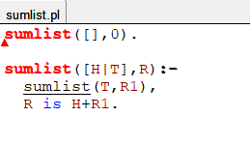

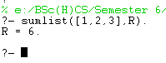

**Ques 13. Write a Prolog program to implement two predicates evenlength(List) and oddlength(List) so that they are true if their argument is a list of even or odd length respectively.**

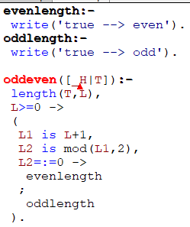

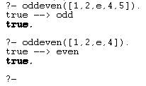

**Ques 15. Write a Prolog program to implement maxlist(L, M) so that M is the maximum number in the list.**



